“Ankur Jain – Fall20 Bootcamp – Student ID 20197VA Md wahidul islam”

**Project & Practical: Manual Testing, Manual Web Testing & Manual Hardware Testing**

Scenario 1:

You work as a Sr. Software Test Engineer at Accenture. Your QA manager, John Smith, has asked you to take the lead on an upcoming project in the QA Pipeline. As part of your responsibilities, you’ve designed a Test Plan and submitted it for approval to John. John has extensive leadership experience in the IT industry and has managed other areas of IT previously. However, John hasn’t had much experience in the Quality Assurance world. After reviewing your Test Plan, John asks for some clarification on some of the sections you’ve created in your Test Plan. Write an Email to John providing more details on the sections he’s asked about (listed below)

- Test Scope (Features to be tested and Features not to be Tested)

- Pass/Fail Criteria

- Entry/Exit Criteria

- Test Deliverables

- Environmental Needs

- Responsibilities

Be sure to provide an explanation for each of the sections mentioned above in your email. Your email should be professional and succinct.

**John smith,**

**As you request to here more clarification about upcoming project that I have been created the test plan on that project below I will explain how we can implement those test plan**

**Test scope**

**Test scope we are going to verify and validate in the project. where we apply the program so we can identify bug and defect efficiently. This way our feature and function will planned for testing.**

**Pass/Fail criteria**

**The pass and fail criteria will apply by testing team after they test the feature of this project if is any bug or defect found we will puss to our developer to look and resend to our test team for retesting.**

**Entry/exit criteria**

**In our project Entry Criteria gives the prerequisite items that must be completed before testing can begin. And Exit Criteria defines the items that must be completed before testing can be concluded. So that why we can build the software more strongly**

**Test Deliverables**

**In test deliverables before we hand over the project to stakeholder, we will tested all module of the future individual and after combining together make sure we calcify that the application is defect free.**

**Environmental**

**Environmental section our test plan should identify what test equipment is already present and what needs to be procured. And what function of feature we will tested.**

**Responsibilities**

**Responsibilities on this project make sure our code and design are suited accordingly the project needs.**

**Thank you**

Scenario 2:

You are a Software QA Professional and are now interviewing at Amazon for your next job. While in the interview, the QA Lead taking your interview asks you to explain the difference between Regression Testing and Ad-hoc testing. Provide a thorough and complete answer to this interview question.

**The difference between ad-hoc testing and regression testing is. Ad-hoc testing is mainly for negative testing and this testing procedure doesn’t have any formal documentation. The tester should test the developed application the way he or she wants, but the intend should always be finding the bugs to provide a bug free application. Now regression testing is a type of software testing that intends to make sure that changes to the software have not adversely affected it.** **Is the software any code change is impacting functionalities that are not directly associated with the code is always there and it is essential that regression testing is conducted to make sure that fixing one thing has not broken another then thing.**

Test Scenario 3: Test Scenarios of ATM Machine (Minimum 5 Test Cases in Excel Sheet) (No Test Steps)

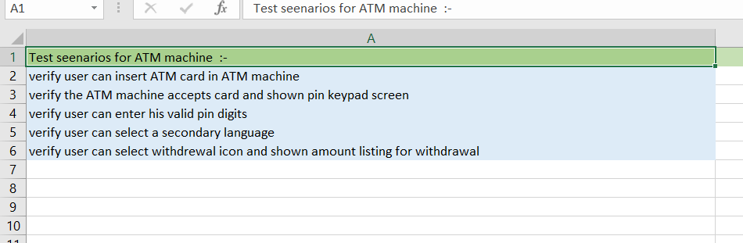

Test Scenario 4: Test scenarios of Bike (Minimum 5 Test Cases in Excel Sheet) (No Test Steps)

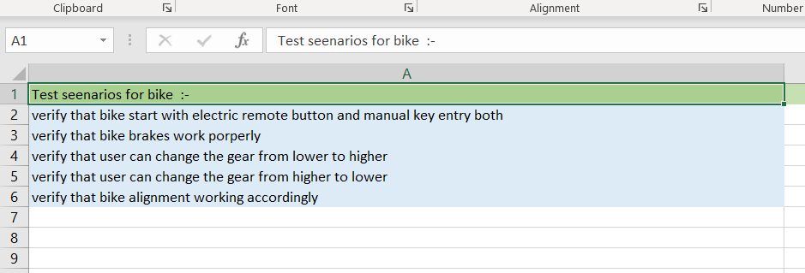

Test Scenario 5: Test Scenarios of Calculator (Minimum 5 Test Cases in Excel Sheet) (No Test Steps)

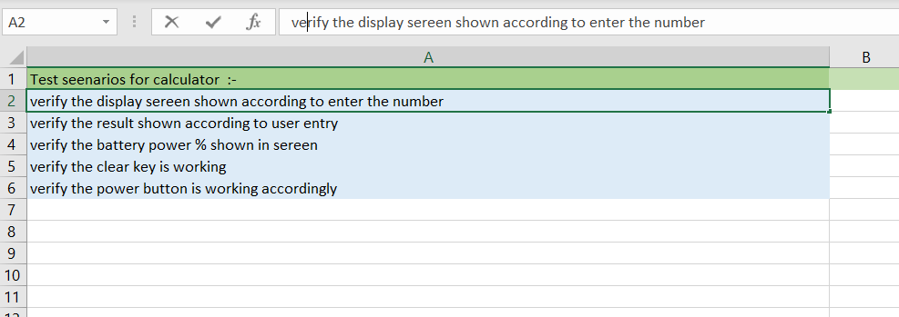

Test Scenario 6: Test Scenarios of Car (Minimum 5 Test Cases in Excel Sheet) (No Test Steps)

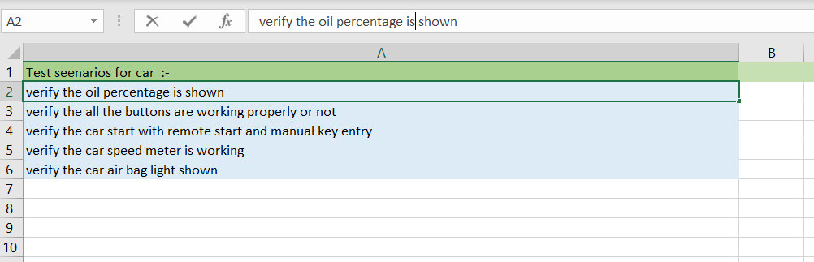

Test Scenario 7: Test Scenarios for Chair (Minimum 5 Test Cases in Excel Sheet) (No Test Steps)

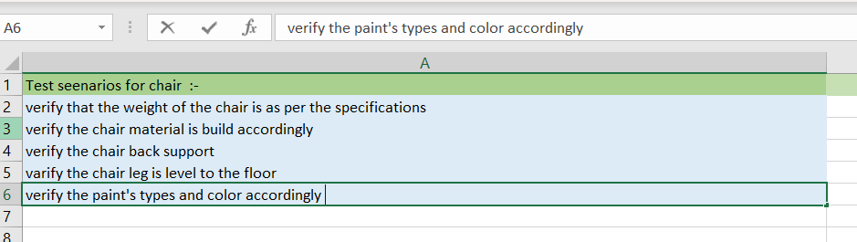

Test Scenario 8: Test cases of Coffee Machine (Minimum 5 Test Cases in Excel Sheet) (No Test Steps)

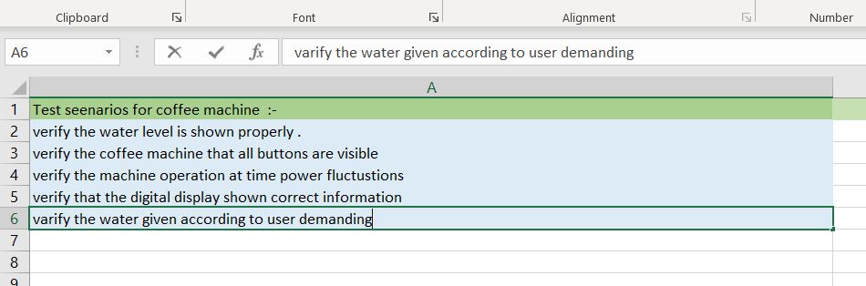

Test Scenario 9: Test Scenarios of Date field (Minimum 5 Test Cases in Excel Sheet) (No Test Steps)

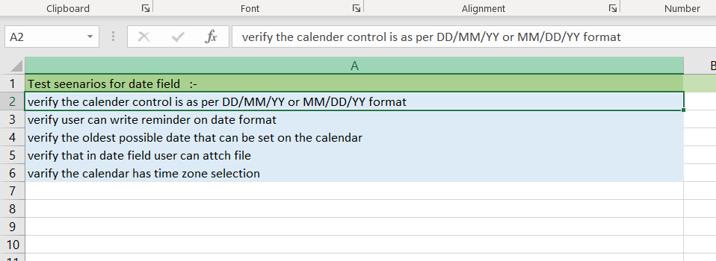

Test Scenario 10: Test cases of Door (Minimum 5 Test Cases in Excel Sheet) (No Test Steps)

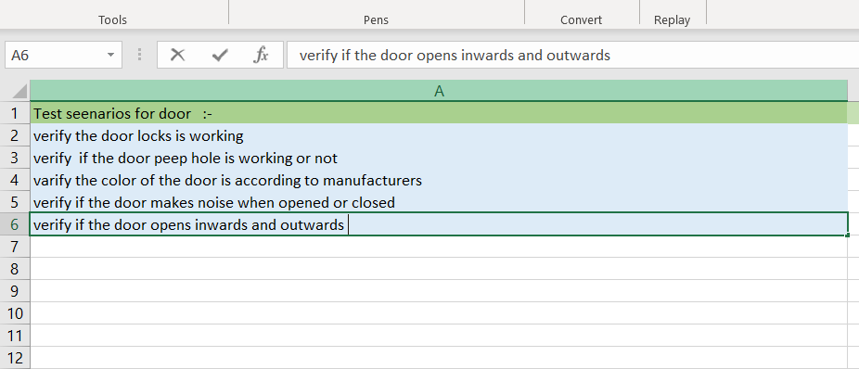

Test Scenario 11: Test cases for Online Shopping Application (Minimum 5 Test Cases in Excel Sheet) (No Test Steps)

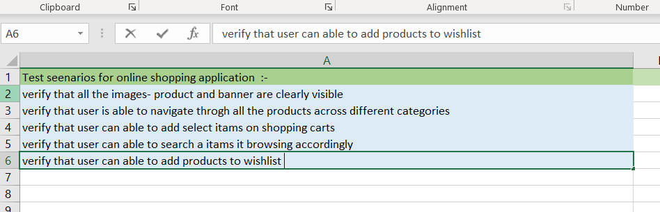

Test Scenario 12: Test Scenarios of Facebook (Minimum 5 Test Cases in Excel Sheet) (No Test Steps)

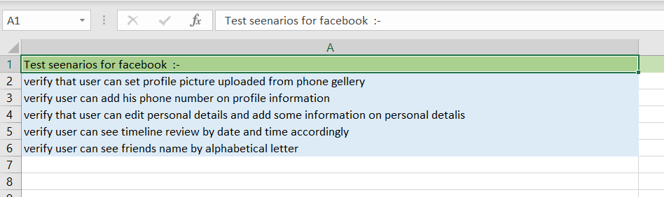

Test Scenario 13: Test scenarios for Fan (Minimum 5 Test Cases in Excel Sheet) (No Test Steps)

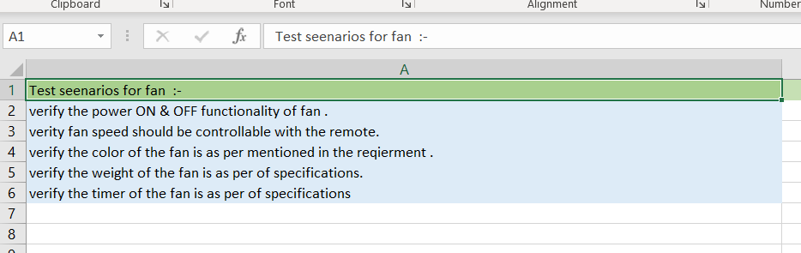

Test Scenario 14: Test Scenarios of Flight Reservation (Minimum 5 Test Cases in Excel Sheet) (No Test Steps)

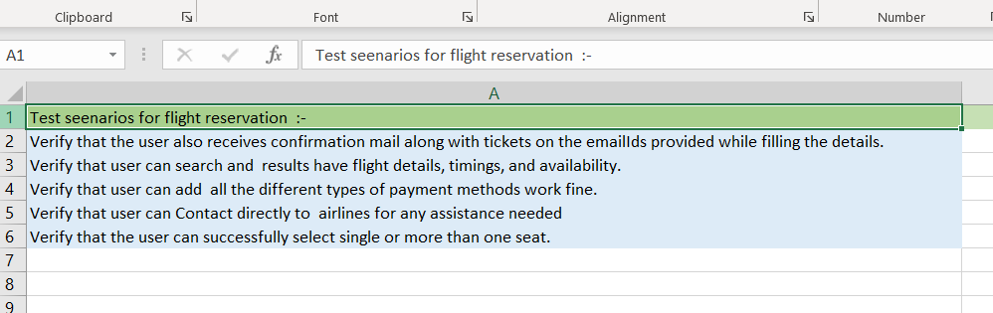

Test Scenario 15: Test Scenarios of Gmail (Minimum 5 Test Cases in Excel Sheet) (No Test Steps)

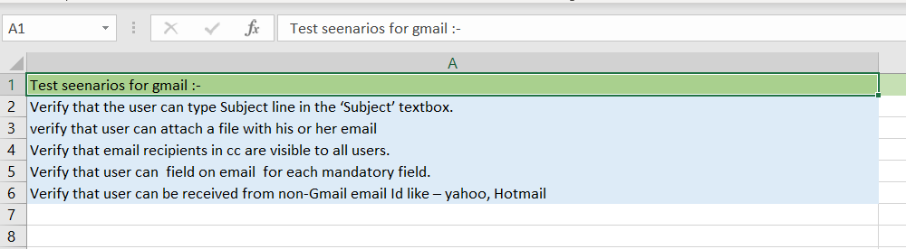

Test Scenario 16: Test scenarios of Google Search (Minimum 5 Test Cases in Excel Sheet) (No Test Steps)

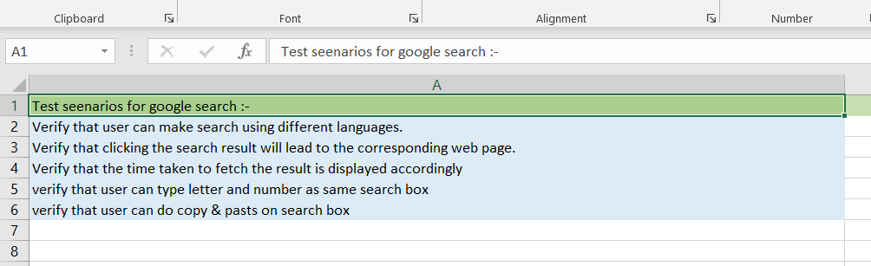

Scenario 17 :-

You are a Software QA Professional and are now interviewing at Google for your next job. While in the interview, the QA Manager taking your interview asks you the following question: “Let’s say you log a bug that you find while executing 1 of your tests cases. But the developer replies back and says that this is not a valid bug. How would you tackle this situation and what would be your next steps?” Provide a thorough and complete answer to this interview question.

**As I a QA tester, my first responsibility give enough evidence that a bug. . For example, I can take a screen shot of that defect and attach to the bug reporting sheet. And send to my test lead or manager. When my manager will review it’s a responsibility of test lead or manager to accept this bug and report to the development team for fixed**

Scenario 18 : Test Scenarios of WhatsApp (Minimum 5 Test Cases in Excel Sheet) (No Test Steps)

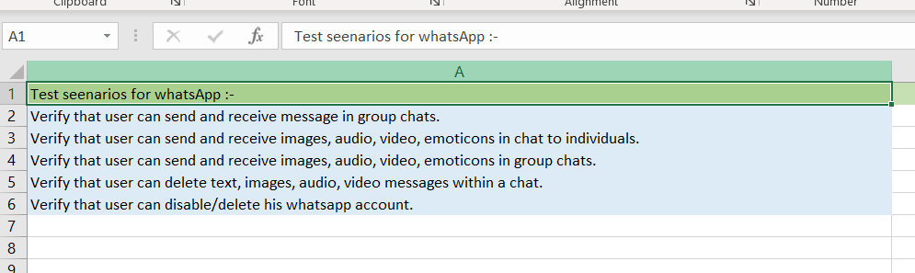

Scenario 19: Test Scenarios of YouTube (Minimum 5 Test Cases in Excel Sheet) (No Test Steps)

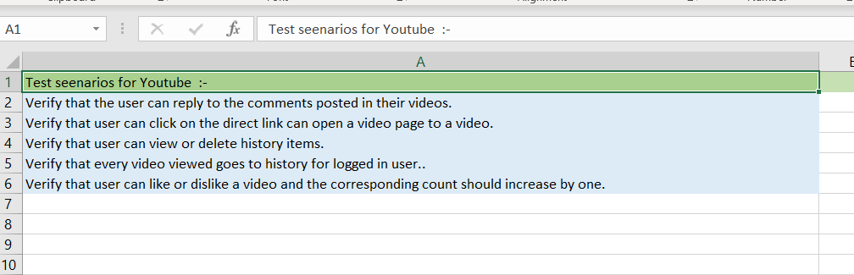

Scenario 20:- Test cases of TV Remote Control (Minimum 5 Test Cases in Excel Sheet)(No Test Steps)

